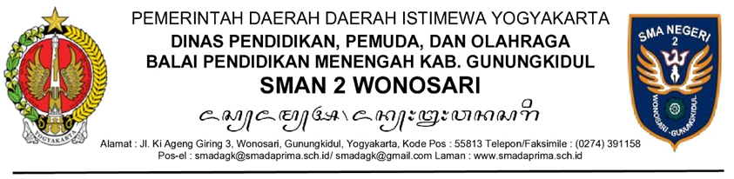

NOTA DINAS

Yth. : ................................................................................................................
Dari : ................................................................................................................
Tembusan : ................................................................................................................
Tanggal : ................................................................................................................
Nomor : ................................................................................................................
Sifat : ................................................................................................................
Lampiran : ................................................................................................................
Hal : ................................................................................................................

........................................................................................................................................................................................................................................................................................................................................................
........................................................................................................................................................................................................................................................................................................................................................
........................................................................................................................................................................................................................................................................................................................................................

Kepala SMAN 2 Wonosari,

Drs. Tiya, M.M.

